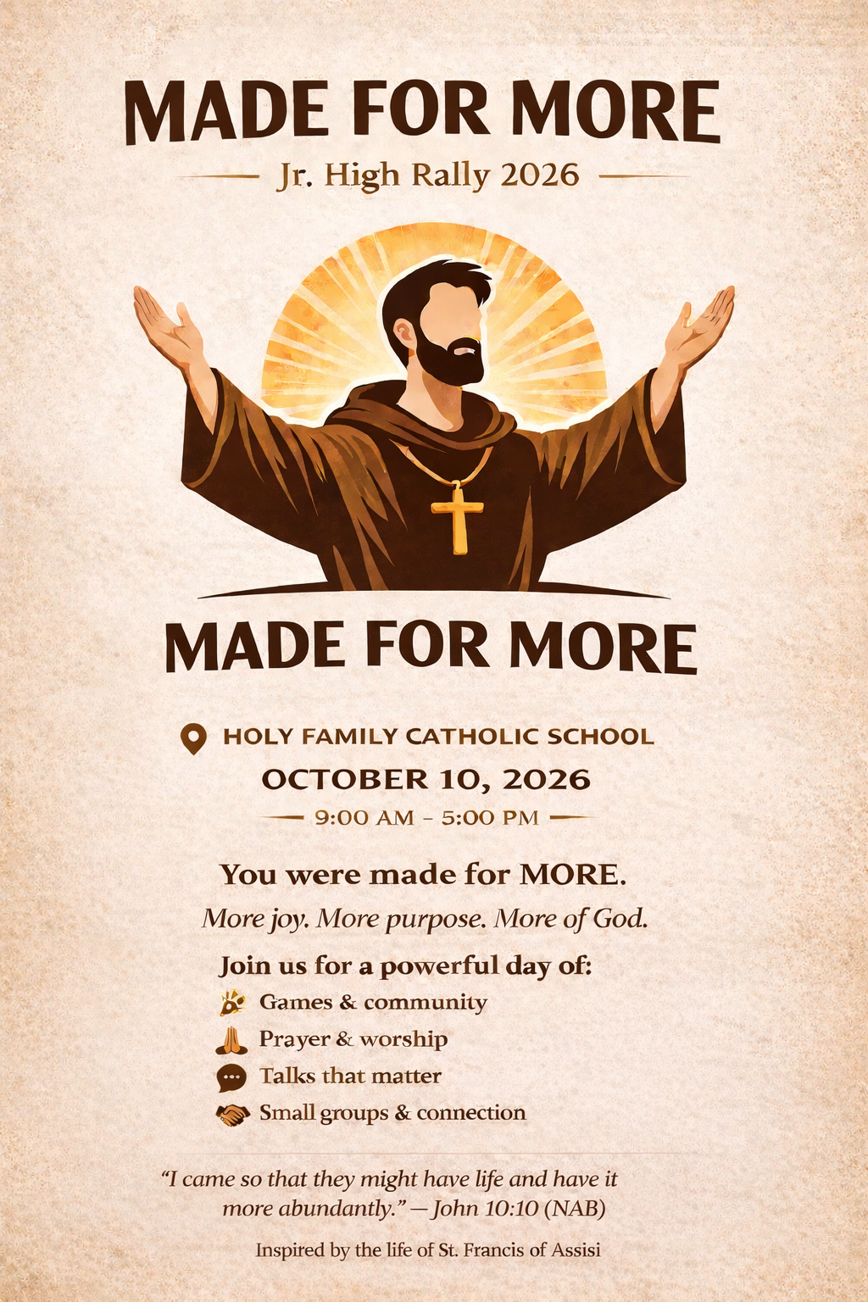
Attention Jr High Students
All junior high students are welcome to join us for this amazing Rally, featuring competitions, formation, and a deep encounter with the Lord!
The Registration Deadline is Sept 23rd for all students
Please contact Sarah Walsh if your student is interested so she can provide the registration form and the youth code of conduct. The cost for the Rally is $30, which includes a T-shirt. We will leave on October 9th at 4:30 pm and stay the night in a classroom at St Pius X School in Coeur d’Alene, ID. Students will need to bring money for fast-food stops on the way up on Friday night and on our way home Saturday night.
Sarah will need a male chaperone who is Safe Environment trained to help transport students and chaperone as well.
Sarah Walsh, Youth Minister
208-507-0528
sarahwalsh_ym@triparishchurches.com

